Lib Restriction solution

If get library restriction errors in code:

1. Right click on project and select properties
2. Select Java Build path
3. Select Add library
4. Select JRE System Library
5. Select Execution environment
6. Select JavaSE-1.7
7. Remove the other lib that is listed in the Java build path

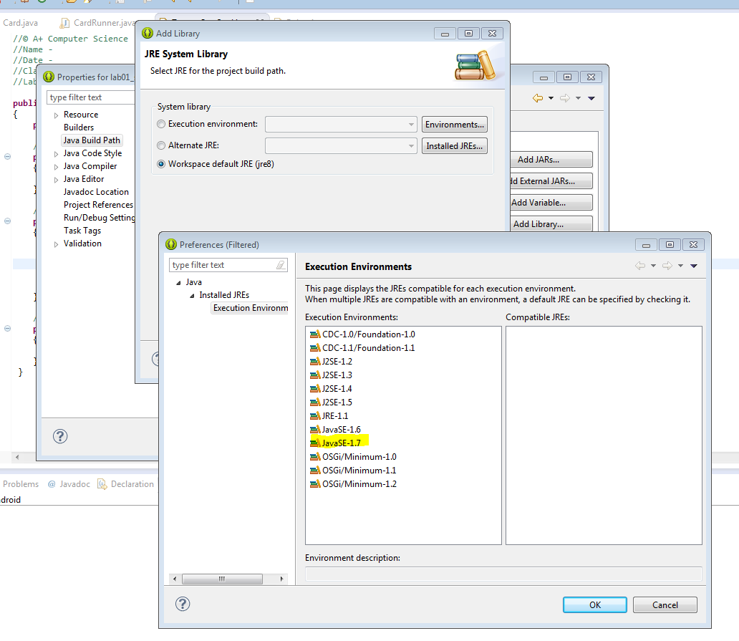

For printf problems

* Right click the project lib and select properties
* Select and pull down the execution environment menu
* Select J2SE-1.5(jre8)